Appliances &
Appliance Recycling
This institution is an equal opportunity provider. |  |  |  |  | 2021 Energy Efficiency Incentive Form
ELIGIBILITY CRITERIA
- New appliance must be on cooperative’s lines. Recycled appliance must have been removed from service on cooperative’s lines.
- New and recycled appliances must be electric.
- Incentive not to exceed the appliance cost. Appliance recycling qualifies for the entire incentive, regardless of the recycling cost.
- Incentives are in place through December 28, 2021. Funds are limited so submit required documentation as soon as possible.
- Required documentation must be submitted within 3 months of purchase or recycle date. If submitted after December 28, 2021, purchase or recycling will be considered for the 2022 incentive if offered.
- Additional eligibility criteria may apply. Program is subject to change or cancellation without notice. Contact cooperative for details.
- Required documentation listed below must be submitted no later than 3 months after purchase or recycle date.
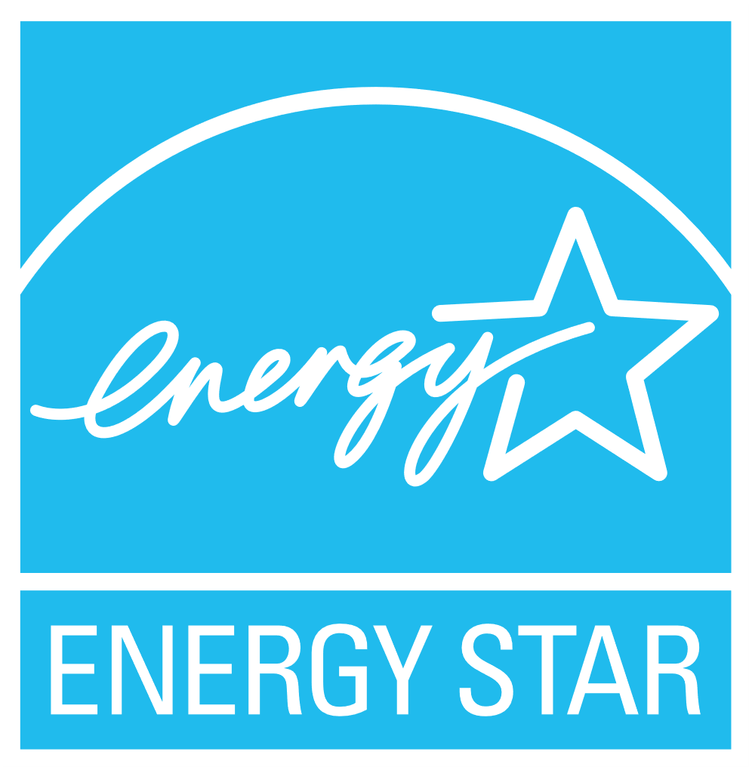
- This incentive form
- A copy of your receipt or invoice for each item with purchase price(s) circled
- ENERGY STAR label for each item, if applicable
- For recycled appliances, include documentation showing appliance was in working order prior to recycling
Submit required documentation to: Oakdale Electric Cooperative, PO Box 40, Oakdale, WI 54649

MEMBER INFORMATION (Please fill out entire section)
Member Name |  |  |  | Email  Email addresses will be used for cooperative communication only.
Address |  |  |  | Account |  |  | Phone
City |  | State | Zip Code | Date |  |  | Member Signature
Incentive for: Residential Farm Commercial Industrial Institution/Government Other:
INCENTIVE INFORMATION (Please fill in gray shaded boxes for requested incentives)
Equipment | Specifications and Required Information |  |  |  |  |  |  | Quantity |  | Incentive | Total  Quantity x Incentive
Clothes Dryer | Must be ENERGY STAR appliance (visit www.energystar.gov to verify) |  |  |  |  |  |  |  |  | $25
Heat Pump Clothes Dryer | All heat pump clothes dryers qualify for the incentive |  |  |  |  |  |  |  |  | $50
Clothes Washer | Must be ENERGY STAR appliance (visit www.energystar.gov to verify) |  |  |  |  |  |  |  |  | $25
Dehumidifier | Must be ENERGY STAR appliance (visit www.energystar.gov to verify) |  |  |  |  |  |  |  |  | $25
Dishwasher | Must be ENERGY STAR appliance (visit www.energystar.gov to verify) |  |  |  |  |  |  |  |  | $25
Freezer | Must be ENERGY STAR appliance (visit www.energystar.gov to verify) |  |  |  |  |  |  |  |  | $25
 | Enter size of freezer (must be minimum of 10 cubic feet):
Inductive Range | All inductive ranges qualify for the incentive |  |  |  |  |  |  |  |  | $25
Refrigerator | Must be ENERGY STAR appliance (visit www.energystar.gov to verify) |  |  |  |  |  |  |  |  | $25
 | Enter size of refrigerator (must be minimum of 10 cubic feet):
Recycling – Freezer | Freezer must be in working order and must be removed from service and fully disposed of following federal, state, and local laws. |  |  |  |  |  |  |  |  | $25
Recycling – Refrigerator | Refrigerator must be in working order and must be removed from service and fully disposed of following federal, state, and local laws. |  |  |  |  |  |  |  |  | $25
Recycling – Room Air Conditioner | Room air conditioner must be in working order and must be removed from service and fully disposed of following federal, state, and local laws. |  |  |  |  |  |  |  |  | $25
Total Incentive Amount Requested:
OFFICE USE ONLY
Approved Not Approved – Reason: |  |  |  |  |  |  |  |  | Total Incentive Issued: $
Cooperative Representative: |  |  |  |  |  |  |  |  | Date:

